Title TBD

**Target Journals:** JAMES / GMD

**Goal**: Summer submission

**Authors:** Kalyn Dorheim, Skylar Gering, Robert Gieseke, Corinne Hartin, Leeya Pressburger, Alexey Shiklomanov, Steve Smith, Claudia Tebaldi, Dawn Woodard, Ben Bond-Lamberty

## **Abstract**

**TODO:** final thing to write

## Introduction

**In an era of anthropogenic climate change** [**(Wuebbles et al. 2017)**](https://paperpile.com/c/Gxpdx2/32cS) **the ability to predict future earth system changes and their impacts is important. It has crucial consequences for decision-makers, stakeholders, and the scientific communities** [**(IPCC 2021)**](https://paperpile.com/c/Gxpdx2/4g7x)[**(Kawamiya et al. 2020)**](https://paperpile.com/c/Gxpdx2/vTCD)**.**

* Coupled Earth System Models (ESMs/GCMs) have been and will continue to be important sources of high-resolution sub-annual climate information [(Kawamiya et al. 2020)](https://paperpile.com/c/Gxpdx2/vTCD).
  + They are powerful but require large amounts of computational resources which limits the potential applications of these models [(Nicholls et al. 2020)](https://paperpile.com/c/Gxpdx2/batb) **(+ REF)**
* Physically-based reduced complexity climate models (RCMs) model critical, all be it simplified, large-scale climate dynamics at lower resolutions [(Smith, C. IPCC CH7 cross-sectional box)](https://paperpile.com/c/Gxpdx2/UWgo).
  + RCMs complement ESMs – used together in the scenario generation process both have contributed information to IPCC reports.
  + RCMs can be used in applications that ESMs cannot

**RCMs are highly diverse in terms of structure, features, and complexity, enabling a wide range of applications and analyses.**

* Diversity in implementation & features
  + One-line energy balance models (based on Stefan-Boltzmann law, black/grey body models)
  + Empirical models
  + Impulse response models (FAIR)
  + Higher-complexity RCMs (simple process-based models such as MAGICC & Hector) may model multiple climate variables & incorporate feedback [(Sarofim et al. 2021)](https://paperpile.com/c/Gxpdx2/saWG)
  + Hemispheric temperature, active ocean carbon chemistry, biomes, & feedbacks
* Wide range of applications
  + Probabilistic studies (MAGICC manuscript about staying below 1.5) [(Ou et al. 2021)](https://paperpile.com/c/Gxpdx2/CT8Q)
  + Exploring the effects of incorporating new feedbacks (Woodard et al. 2021) [(Woodard et al. 2021)](https://paperpile.com/c/Gxpdx2/q1Aj) coupling with other models (Hartin et al. 2021)
  + **[Transition needed!]**

**One such example of a higher-complexity RCM is Hector, first described in** [**(Hartin et al. 2015)**](https://paperpile.com/c/Gxpdx2/WEra) **is Hector, a globally resolved simple carbon model.**

* Active terrestrial carbon cycle and ocean carbon components with carbon-climate feedbacks/interactions its temperature component [energy balance model/DOECLIM]
* Hector is used at the climate component of GCAM (Calvin et al. 2019) - used in a number of socio-economic studies [citations needed], participated in two phases of RCMIP (Nicholls et al. 2020; Nicholls et al. 2021), and was calibrated to emulate the CMIP5 models (Dorheim et al. 2020).
* Since Hector’s debut in 2015 the model has undergone a number of changes

**The objective of this manuscript is to document the latest version of Hector, the v3 release.**

* We will discuss major changes since Hector v1 (updates to Hector’s forcing component, integrating DOECLIM as the temperature component, and migrating to the SSP scenarios, structural reorganization into an R package)
* Document new features (carbon tracking, new parameters, permafrost feedbacks & new constraints)
* Concluding with a comparison between Hector v3 results with observations and output from the CMIP6 ESM.

## Methods

### Updates from V1

**Hector's model structure and design architecture are largely unchanged since Hector v1.**

* As described in Hartin et al., Hector is a self-contained object-oriented model organized into components by scientific areas.
* The C++ compiled Hector executable can easily be coupled to other models or run from the command line or with a C++ IDE (Xcode/VS).
* Free running Hector uses external emission time series (GCAM, model-generated, or from IIASA scenarios) → concentrations (carbon cycle dynamics, simple atmospheric chemistry) → radiative forcing → temperature
* Alternatively, a number of variables can be *constrained*, giving users the ability to bypass specific Hector components by prescribing a target (CO2, temperature, land-atmosphere C exchange) that the model must hit.
* Here we focus primarily on the changes and upgrades made to Hector since Hartin et al. 2015.

**A number of software upgrades have increased Hector’s robustness, accessibility, and reproducibility.**

* Update project solutions to enable Hector to run compile and run on various platforms using various IDEs (Visual Stuido, Xcode)
* Expanded and improved automated unit testing that is regularly deployed via github actions
* Most significant software change was the reorganization of the code into an R package, work led by R. Link (see Acknowledgments)
  + The overall structure and design of C++ codebase remain unchanged from Hartin et al. [(Hartin et al. 2015)](https://paperpile.com/c/Gxpdx2/WEra)
  + Rcpp is used to pass information between the C++ code base and the R code base that makes up the hector package (Rhector)
* Advantages of the R package to users
  + users are able to install, build, deploy, analyze and visualize Hector results all within R, one of the most common languages for statistical computing [(Wilson et al. 2014)](https://paperpile.com/c/Gxpdx2/IIFh)
  + Increases reproducibility
  + Improved documentation (between R doxygen & pkgdown) and automated testing
* Using the R package there is the shiny app, HectorUI (Evanoff et al. 2020) that provides users with the ability to run Hector via “point and click” – no coding required
* These software developments inline with Hector’s fundamental goal to be an accessible and open source model

**The new features and science upgrades to Hector…. [improve performance, something about evolving with the needs of the community and recent scientific consensus reported in the IPCC reports]**

New Features

* Expanded Hector’s constraint capabilities users can prescribe non CO2 greenhouse gases and NBP
* New scalar parameters to adjust aerosol and volcanic effective radiative forcing
  + Allows for better calibration to specific ESMs
  + Opens the door for more uncertainty analyses
* Carbon tracking
  + Description of capability
* Permafrost
  + Brief description of how it works reference Dawn’s manuscript

New Science

* Temperature component replaced with DOECLIM
* Updated default parameters
  + When available from IPPC AR6 report (tables)
  + Calibration method calibrated parameters

## Data Description

* Output from Hector v3 using
  + SSP scenarios (RCMIP or AR6)?
  + RCP scenarios
* Archived RCP output from Hector < v2. 5
* Description of processing that went into the observational/comparison data
  + HadCrut – [(Morice et al. 2012)](https://paperpile.com/c/Gxpdx2/x7MI)
  + CMIP6 variables processed
* Error metrics/goodness of fit
  + To be determined

## Results

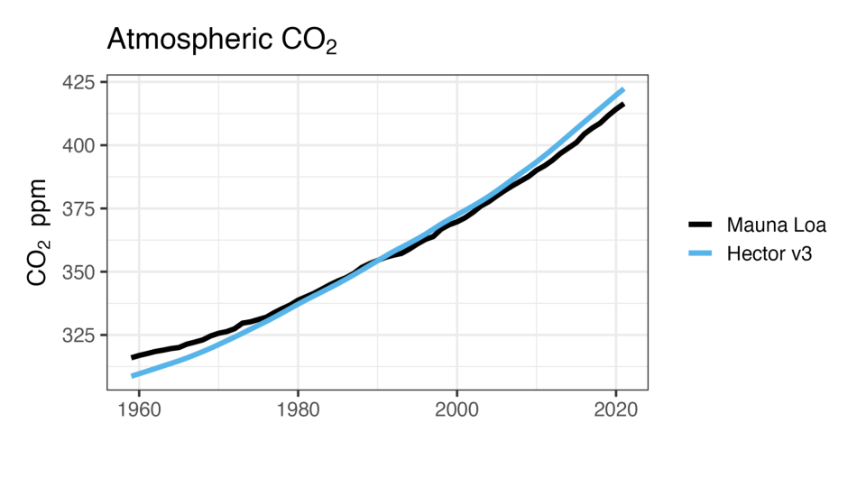

Figure 1: Emission-driven Hector atmospheric CO2 concentrations compared with historical observations.

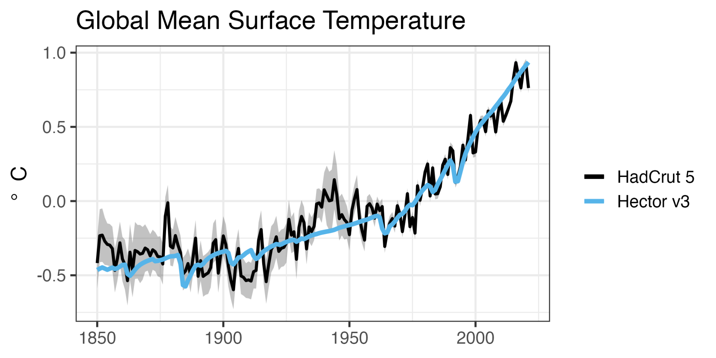

Figure 2: Emission-driven Hector global mean surface temperature compared with historical observations.

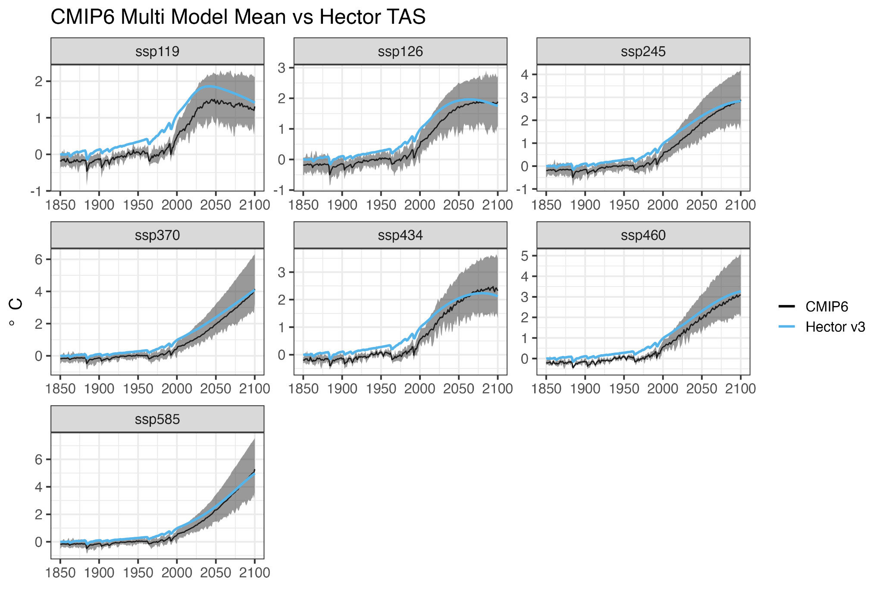

Figure 3: Emission-driven Hector global mean air temperature (blue) compared with CMIP6 results. The black line is the CMIP6 multi-model mean, and the grey envelope is the CMIP6 spread.

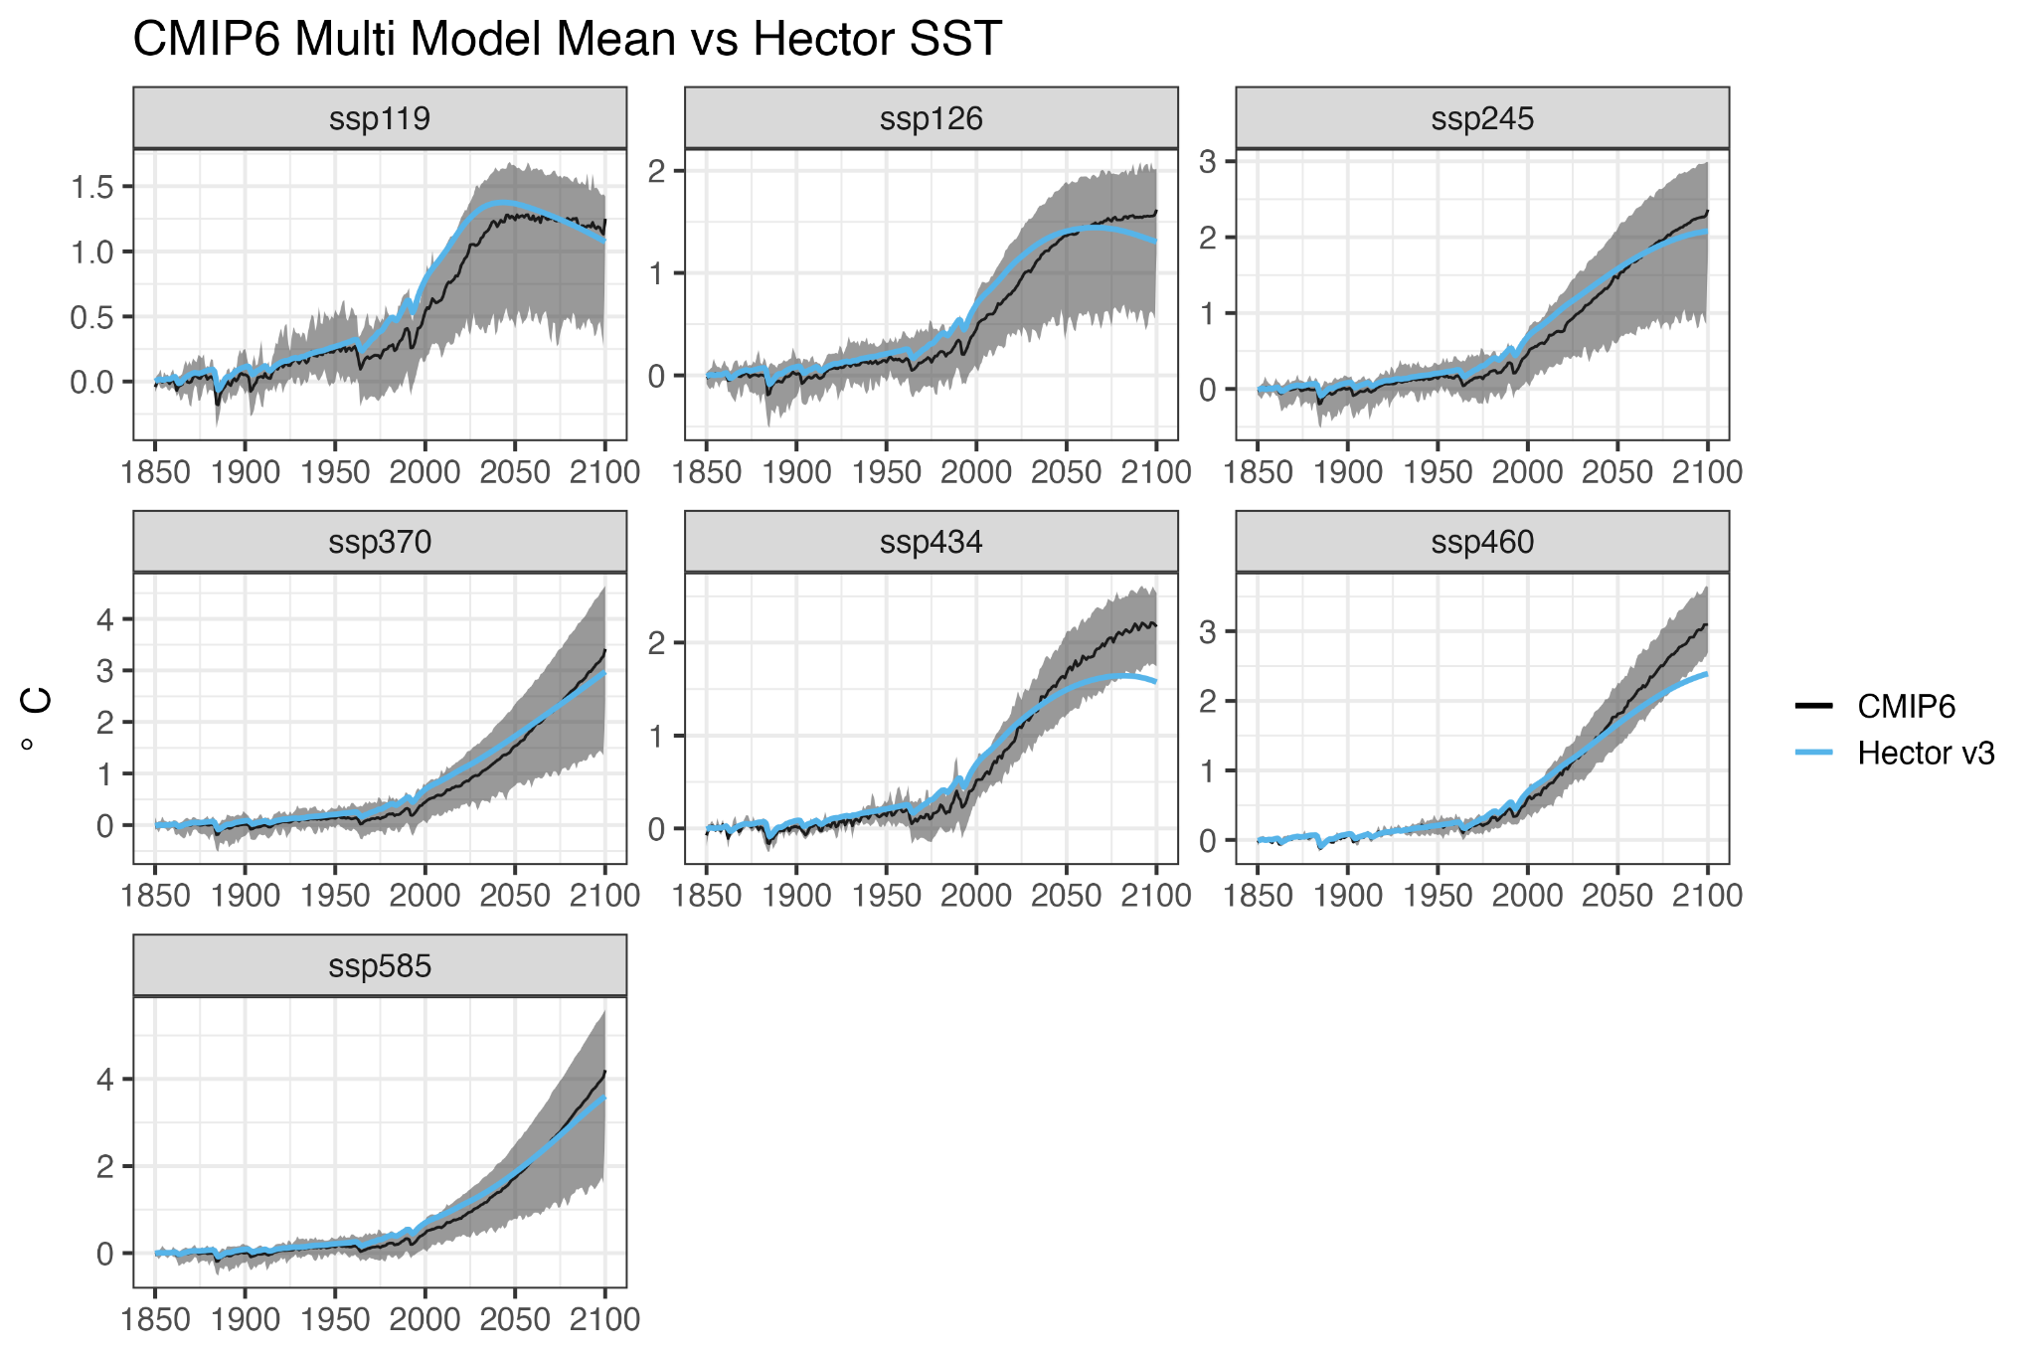

Figure 4: Emission-driven Hector global sea surface temperature (blue) compared with CMIP6 results. The black line is the CMIP6 multi-model mean, and the grey envelope is the CMIP6 spread.

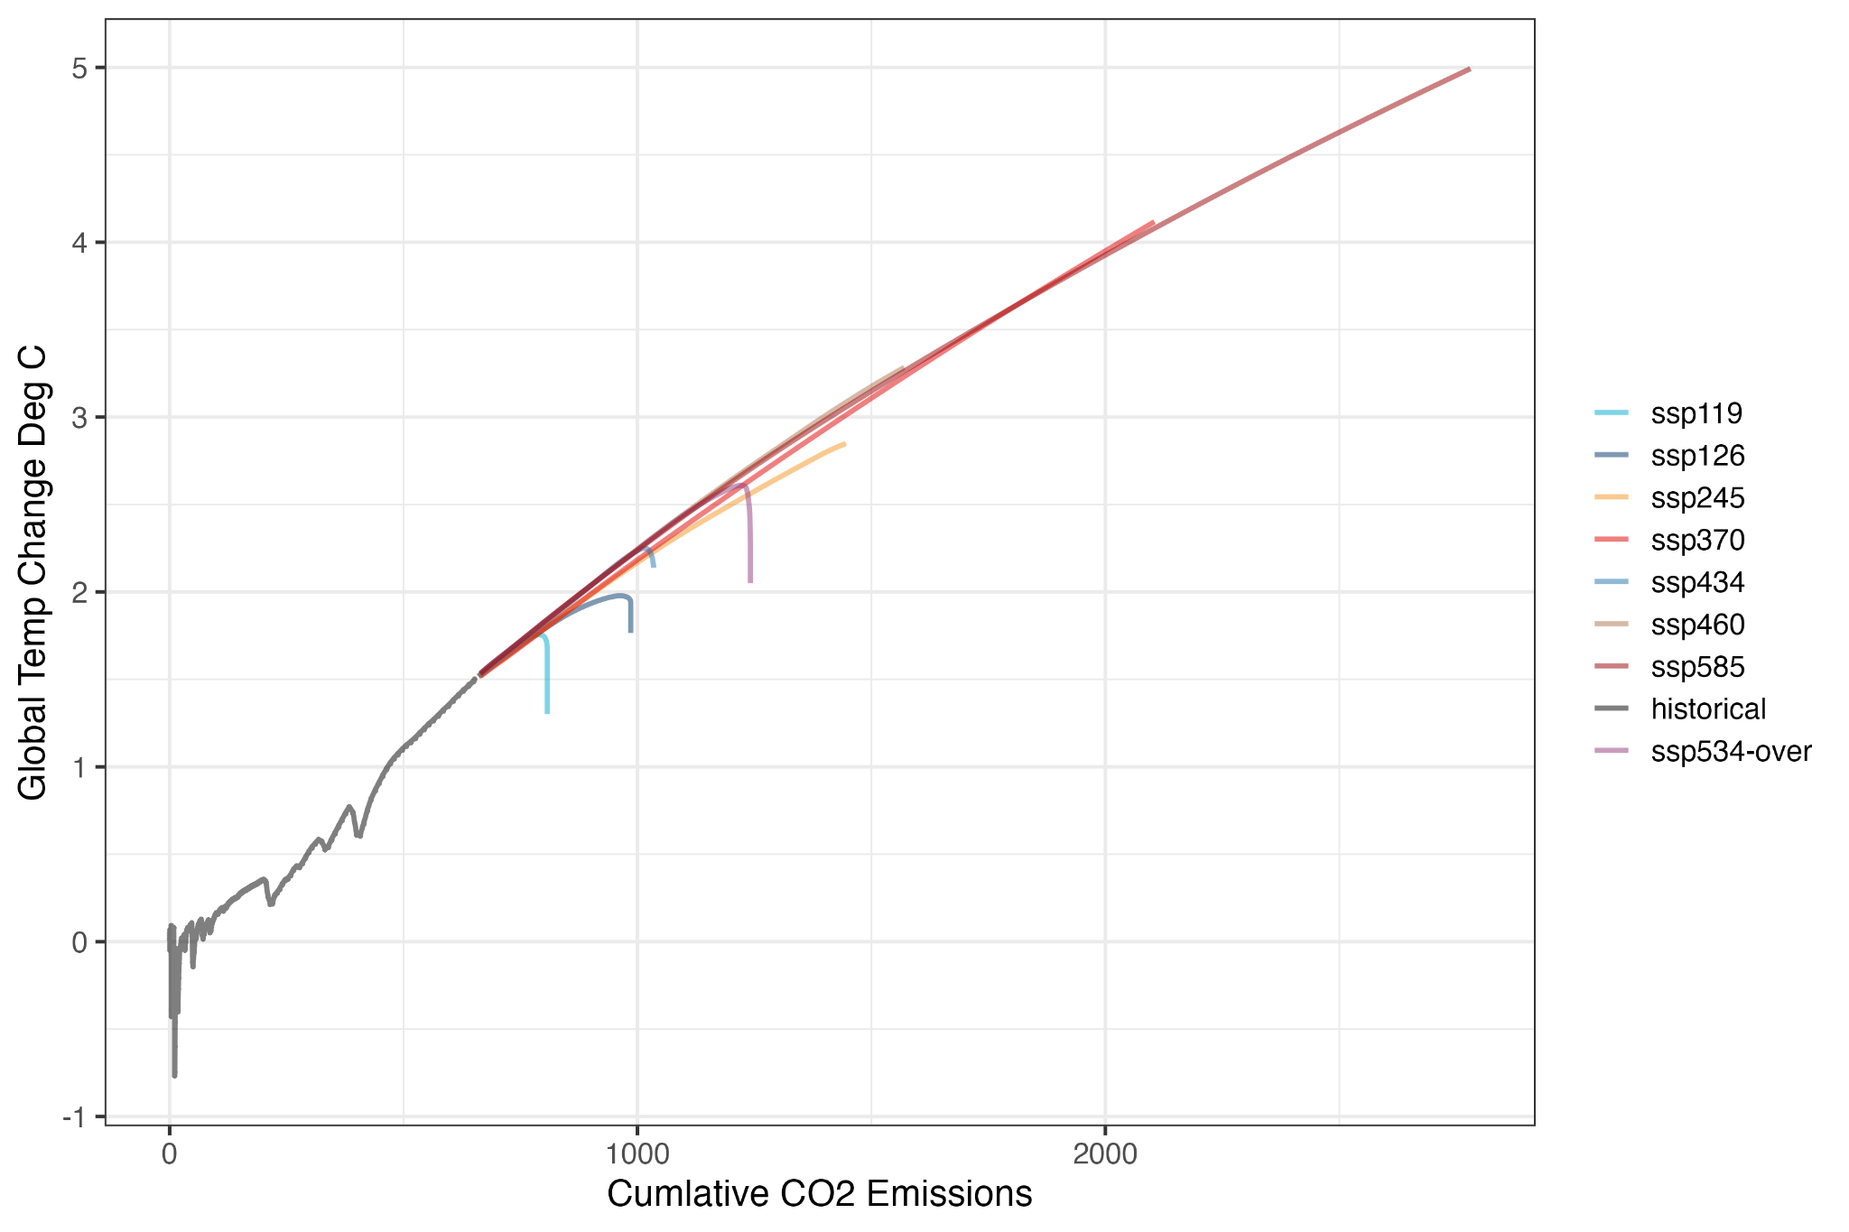

Figure 5: Cumulative CO2 emissions and global mean annual air temperature change relative to pre-industrial (1750?)

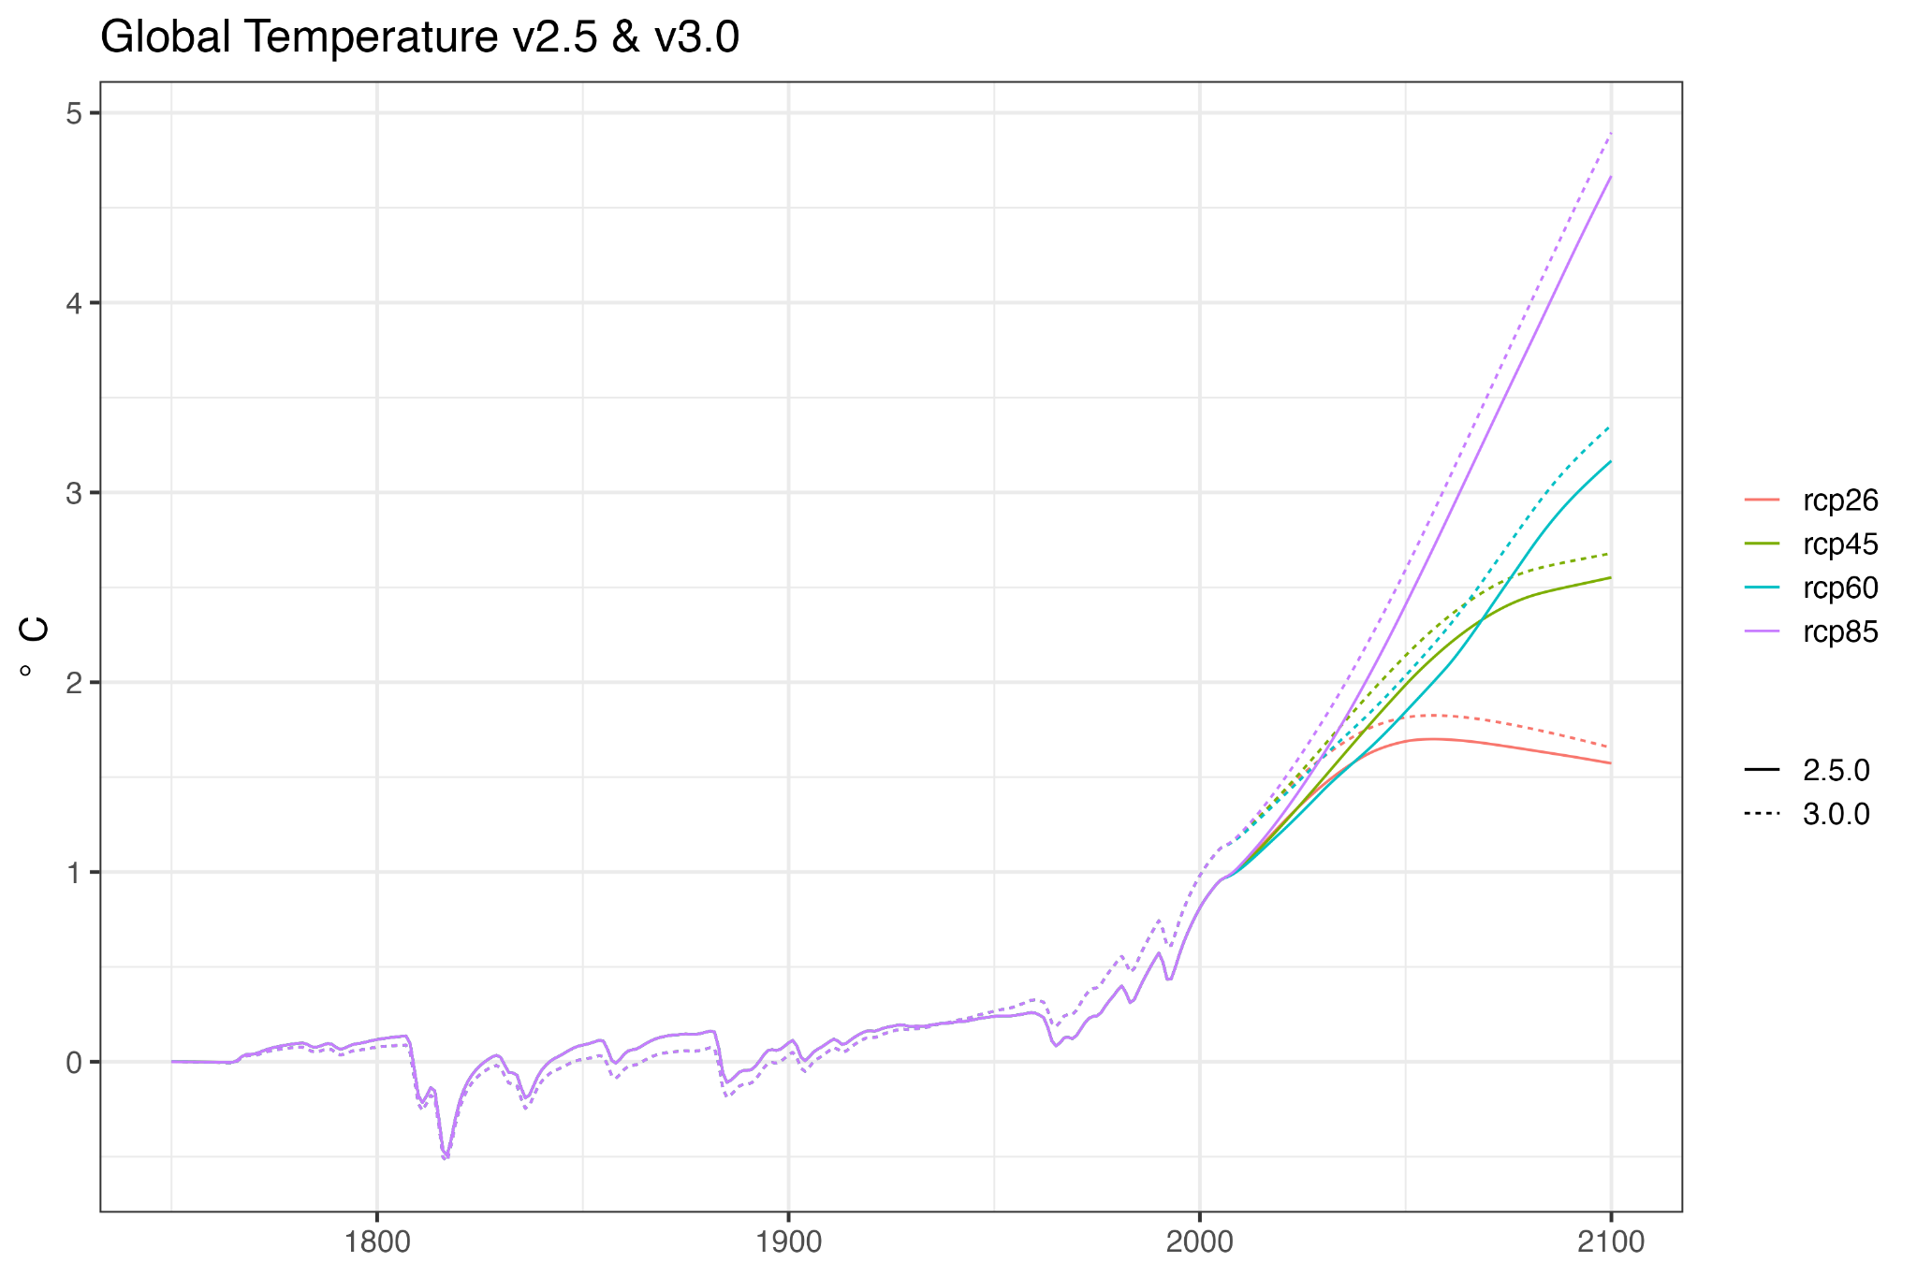

Figure 6: Comparison of global mean air temperature from the two different versions of Hector.

## Discussion

* Main takeaways
  + How much has Hector changed (temperature-wise) future and historical
* Future development ideas/goals
  + Ideas for how new features will be used?
  + What would be important to add to Hector?
* Close with some connection to the larger SCM/emulator community

## 

## 

## 

## Appendix

### Table of Misc. Hector Parameters

| **Parameter** | **Value** | **Units** | **Source** |
| --- | --- | --- | --- |
| NPP0 | 56.2 | Pg C/yr | [(Ito 2011)](https://paperpile.com/c/Gxpdx2/5NEF) |
|  | 3.75 |  | 7.3.2 of IPCC AR6 [(Forster, P., T. Storelvmo, K. Armour,...)](https://paperpile.com/c/Gxpdx2/2yS9) |
| Surface C0 | 900 | Pg C | Figure 5.12  [(da Cunha, P. M. Cox, A. V. Eliseev, S...)](https://paperpile.com/c/Gxpdx2/hZs6) |
| Interior C0 | 37100 | Pg C | Figure 5.12  [(da Cunha, P. M. Cox, A. V. Eliseev, S...)](https://paperpile.com/c/Gxpdx2/hZs6) |
| TOS0 | 18 | C | hector_cmip6data |
|  | -16.4 | C | hector_cmip6data |
|  | 2.9 | C | hector_cmip6data |

### 

### Equations

#### Radiative Forcing

##### CO2

Where [](https://latex-staging.easygenerator.com/eqneditor/editor.php?latex=N#0) and [](https://latex-staging.easygenerator.com/eqneditor/editor.php?latex=C#0) are atmospheric concentrations of N2O and CO2 respectively, the equations use the following parameterizations.

[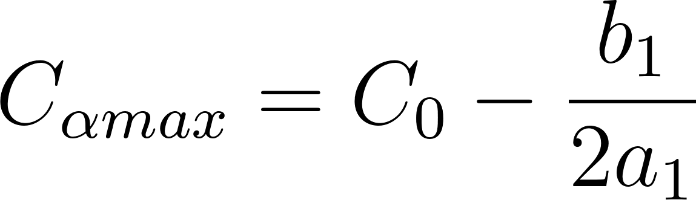](https://latex-staging.easygenerator.com/eqneditor/editor.php?latex=%7BC%7D_%7B%5Calpha%20max%7D%20%3D%20%7BC%7D_%7B0%7D%20-%20%5Cfrac%7Bb_1%7D%7B2a_1%7D#0)

[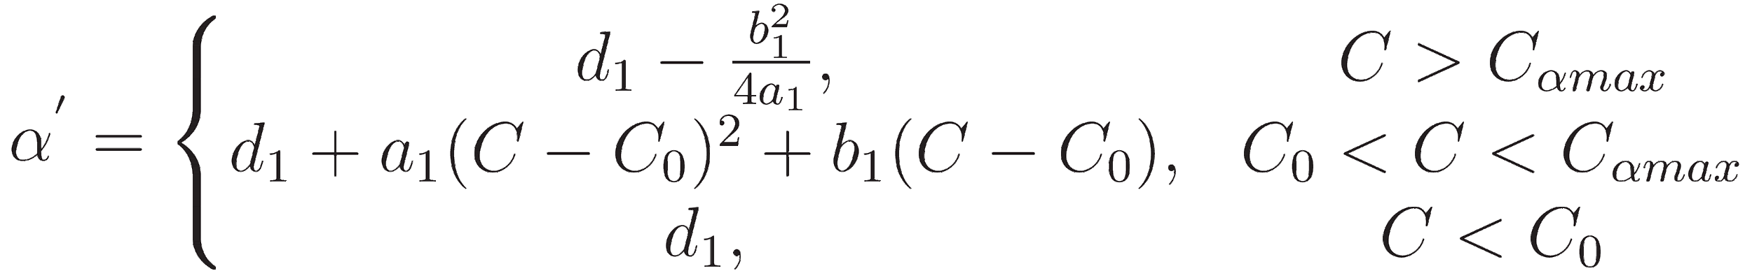](http://www.sciweavers.org/tex2img.php?bc=Transparent&fc=Black&im=jpg&fs=100&ff=modern&edit=0&eq=%5Calpha%5E%7B'%7D%20%3D%20%5Cleft%5C%7B%5Cbegin%7Bmatrix%7D%20%7Bd%7D_%7B1%7D%20-%20%5Cfrac%7B%7Bb%7D%5E%7B2%7D_%7B1%7D%7D%7B4%7Ba%7D_%7B1%7D%7D%2C%20%26%20%5Ctext%7B%20%24C%3EC_%7B%5Calpha%20max%7D%24%7D%5C%5C%5C%5C%20%7Bd%7D_%7B1%7D%20%2B%20%7Ba%7D_%7B1%7D(C-%7BC%7D_%7B0%7D)%5E2%20%2B%20b_%7B1%7D(C%20-%20%7BC%7D_%7B0%7D)%2C%20%26%20%5Ctext%7B%24C_%7B0%7D%20%3C%20C%20%3C%20%7BC%7D_%7B%5Calpha%20max%7D%24%7D%5C%5C%5C%5C%20%7Bd%7D_%7B1%7D%2C%20%20%26%20%5Ctext%7B%24C%20%3C%20%7BC%7D_%7B0%7D%24%7D%5Cend%7Bmatrix%7D#0)

[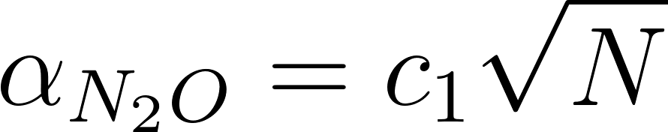](https://latex-staging.easygenerator.com/eqneditor/editor.php?latex=%5Calpha_%7BN_%7B2%7DO%7D%20%3D%20c_%7B1%7D%20%5Csqrt%7BN%7D#0)

[](https://latex-staging.easygenerator.com/eqneditor/editor.php?latex=%7BSARF%7D_%7BCO_%7B2%7D%7D%20%3D%20(%7B%5Calpha%7D%5E%7B'%7D%20%2B%20%5Calpha_%7BN_%7B2%7DO%7D)%20%5Cln(C%2FC_%7B0%7D)#0)

###### 

| **Equation** | **Parameters** | **Value** | **Units** | **Source** |
| --- | --- | --- | --- | --- |
| CO2 Radiative Forcing | *a1* | -2.4785e-7 | (W m–2 ppm–2) | Table 7.SM.1[(Smith, C., Z. R. J. Nicholls, K. Armo...)](https://paperpile.com/c/Gxpdx2/UWgo) |
| CO2 Radiative Forcing | b1 | 7.5906e-4 | (W m–2 ppm–2) | Table 7.SM.1[(Smith, C., Z. R. J. Nicholls, K. Armo...)](https://paperpile.com/c/Gxpdx2/UWgo) |
| CO2 Radiative Forcing | c1 | -2.1492e-3 | (W m–2 ppb–1/2) | Table 7.SM.1[(Smith, C., Z. R. J. Nicholls, K. Armo...)](https://paperpile.com/c/Gxpdx2/UWgo) |
| CO2 Radiative Forcing | d1 | 5.2488 | (W m–2) | Table 7.SM.1[(Smith, C., Z. R. J. Nicholls, K. Armo...)](https://paperpile.com/c/Gxpdx2/UWgo) |
| CO2 Radiative Forcing |  | 0.05 | unitless | 7.3.2.3 [(Forster, P., T. Storelvmo, K. Armour,...)](https://paperpile.com/c/Gxpdx2/2yS9) |

##### N2O

Where [](https://latex-staging.easygenerator.com/eqneditor/editor.php?latex=N#0), [](https://latex-staging.easygenerator.com/eqneditor/editor.php?latex=C#0), [](https://latex-staging.easygenerator.com/eqneditor/editor.php?latex=M#0) are atmospheric concentrations of N2O, CO2, and CH4 respectively, the equations use the following parameterizations.

[](https://latex-staging.easygenerator.com/eqneditor/editor.php?latex=SARF_%7BN_%7B2%7DO%7D%20%3D%20%5Cleft(%20a_%7B2%7D%5Csqrt%7BC%7D%20%2B%20b_%7B2%7D%20%5Csqrt%7BN%7D%20%2B%20%7Bc%7D_%7B2%7D%5Csqrt%7BM%7D%20%2B%20%7Bd%7D_%7B2%7D%20%5Cright)%20%5Cleft(%20%5Csqrt%7BN%7D%20-%20%5Csqrt%7BN_%7B0%7D%7D%20%5Cright)#0)

[](https://latex-staging.easygenerator.com/eqneditor/editor.php?latex=%7BRF%7D_%7BN_%7B2%7DO%7D%20%3D%20%5Cdelta_%7BN_%7B2%7DO%7D%20%20SARF_%7BN_%7B2%7DO%7D%20%20%2B%20SARF_%7BN_%7B2%7DO%7D%20#0)

| **Equation** | **Parameters** | **Value** | **Units** | **Source** |
| --- | --- | --- | --- | --- |
| N2O radiative forcing | a2 | -3.4197e-4 | (W m–2 ppm–1) | Table 7.SM.1[(Smith, C., Z. R. J. Nicholls, K. Armo...)](https://paperpile.com/c/Gxpdx2/UWgo) |
| N2O radiative forcing | b2 | 2.5455e-4 | (W m–2 ppb–1) | Table 7.SM.1[(Smith, C., Z. R. J. Nicholls, K. Armo...)](https://paperpile.com/c/Gxpdx2/UWgo) |
| N2O radiative forcing | c2 | -2.4357e-4 | (W m–2 ppb–1) | Table 7.SM.1[(Smith, C., Z. R. J. Nicholls, K. Armo...)](https://paperpile.com/c/Gxpdx2/UWgo) |
| N2O radiative forcing | d2 | 0.12173 | (W m-2 ppb–1/2) | Table 7.SM.1[(Smith, C., Z. R. J. Nicholls, K. Armo...)](https://paperpile.com/c/Gxpdx2/UWgo) |
| N2O radiative forcing | N0 | 273.87 | ppb |  |
| N2O radiative forcing |  | 0.05 | unitless | 7.3.2.3 [(Forster, P., T. Storelvmo, K. Armour,...)](https://paperpile.com/c/Gxpdx2/2yS9) |

##### CH4

Where [](https://latex-staging.easygenerator.com/eqneditor/editor.php?latex=N#0) and [](https://latex-staging.easygenerator.com/eqneditor/editor.php?latex=M#0) are atmospheric concentrations of N2O and CH4 respectively, the equations use the following parameterizations.

[](https://latex-staging.easygenerator.com/eqneditor/editor.php?latex=SARF_%7BCH_%7B4%7D%7D%20%3D%20%5Cleft(%20a_%7B3%7D%5Csqrt%7BM%7D%20%2B%20b_%7B3%7D%20%5Csqrt%7BN%7D%20%2B%20d_%7B3%7D%20%5Cright)%20%5Cleft(%20%5Csqrt%7BM%7D%20-%20%5Csqrt%7BM_%7B0%7D%7D%20%5Cright)#0)

[](https://latex-staging.easygenerator.com/eqneditor/editor.php?latex=%7BRF%7D_%7BCH_%7B4%7D%7D%20%3D%20%5Cdelta_%7BCH_%7B4%7D%7D%20%20SARF_%7BCH_%7B4%7D%7D%20%20%2B%20SARF_%7BCH_%7B4%7D%7D#0)

| **Equation** | **Parameters** | **Value** | **Units** | **Source** |
| --- | --- | --- | --- | --- |
| CH4 radiative forcing | a3 | -8.9603e-5 | W m–2 ppb–1 | Table 7.SM.1[(Smith, C., Z. R. J. Nicholls, K. Armo...)](https://paperpile.com/c/Gxpdx2/UWgo) |
| CH4 radiative forcing | b3 | -1.2462e-4 | W m–2 ppb–1 | Table 7.SM.1[(Smith, C., Z. R. J. Nicholls, K. Armo...)](https://paperpile.com/c/Gxpdx2/UWgo) |
| CH4 radiative forcing | d3 | 0.045194 | W m–2 ppb–1/2 | Table 7.SM.1[(Smith, C., Z. R. J. Nicholls, K. Armo...)](https://paperpile.com/c/Gxpdx2/UWgo) |
| CH4 radiative forcing |  | -0.14 | unitless | 7.3.2.3 [(Forster, P., T. Storelvmo, K. Armour,...)](https://paperpile.com/c/Gxpdx2/2yS9) |

##### Halocarbons

[](https://latex-staging.easygenerator.com/eqneditor/editor.php?latex=%7BSARF%7D_%7Bx%7D%20%3D%20%5Crho_%7Bx%7D%20%20%7B%5BX%5D%7D#0)

[](https://latex-staging.easygenerator.com/eqneditor/editor.php?latex=%7BRF%7D_%7Bx%7D%20%3D%20%20%7BSARF%7D_%7Bx%7D%20%20%2B%20%5Cdelta_%7Bx%7D%7BSARF%7D_%7Bx%7D#0)

Table ??: Table 7.SM.7 from IPCC AR6 Report [(Smith, C., Z. R. J. Nicholls, K. Armo...)](https://paperpile.com/c/Gxpdx2/UWgo)

| **Halocarbon** | **(lifetime)** | **(Radiative efficiency)** | **(tropospheric adjustments)** |
| --- | --- | --- | --- |
| CF4 | 50000.0 | 0.000099 | 0 |
| C2F6 | 10000.0 | 0.000261 | 0 |
| HFC-23 | 228.0 | 0.000191 | 0 |
| HFC-32 | 5.4 | 0.000111 | 0 |
| HFC-4310 | 17.0 | 0.000357 | 0 |
| HFC-125 | 30.0 | 0.000234 | 0 |
| HFC-134a | 14.0 | 0.000167 | 0 |
| HFC-143a | 51.0 | 0.000168 | 0 |
| HFC-227ea | 36.0 | 0.000273 | 0 |
| HFC-245fa | 7.9 | 0.000245 | 0 |
| SF6 | 3200.0 | 0.000567 | 0 |
| CFC-11 | 52.0 | 0.000259 | 0.13 |
| CFC-12 | 102.0 | 0.00032 | 0.13 |
| CFC-113 | 93.0 | 0.000301 | 0 |
| CFC-114 | 189 | 0.000314 | 0 |
| CFC-115 | 540 | 0.000246 | 0 |
| CCl4 | 32 | 0.000166 | 0 |
| CH3CCl3 | 5 | 0.000065 | 0 |
| halon-1211 | 16.0 | 0.0003 | 0 |
| halon-1301 | 72.0 | 0.000299 | 0 |
| halon-2402 | 28.0 | 0.000312 | 0 |
| HCFC-22 | 11.9 | 0.000214 | 0 |
| HCFC-141b | 9.4 | 0.000161 | 0 |
| HCFC-142b | 18.0 | 0.000193 | 0 |
| CH3Cl | 0.9 | 0.000005 | 0 |
| CH3Br | 0.8 | 0.000004 | 0 |

##### Aerosols

[](https://latex-staging.easygenerator.com/eqneditor/editor.php?latex=%7BRF%7D_%7BBC%7D%20%3D%20%5Crho_%7BBC%7D%20E_%7BBC%7D#0)

[](https://latex-staging.easygenerator.com/eqneditor/editor.php?latex=%7BRF%7D_%7BOC%7D%20%3D%20%5Crho_%7BOC%7D%20E_%7BOC%7D#0)

[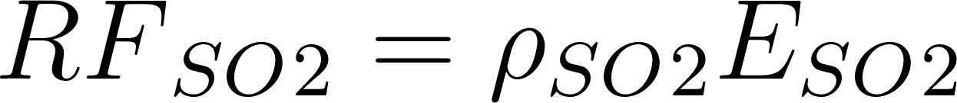](https://latex-staging.easygenerator.com/eqneditor/editor.php?latex=%7BRF%7D_%7BSO%7D_%7B2%7D%20%3D%20%5Crho_%7BSO%7D_%7B2%7D%20E_%7BSO%7D_%7B2%7D#0)

[](https://latex-staging.easygenerator.com/eqneditor/editor.php?latex=%7BRF%7D_%7BNH%7D_%7B3%7D%20%3D%20%5Crho_%7BNH%7D_%7B3%7D%20E_%7BNH%7D_%7B3%7D#0)

Aerosol-cloud Interactions

[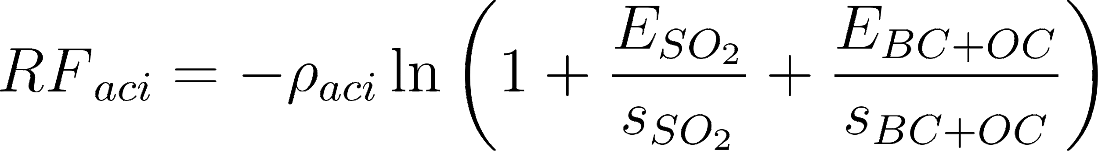](https://latex-staging.easygenerator.com/eqneditor/editor.php?latex=%7BRF%7D_%7Baci%7D%20%3D%20-%5Crho_%7Baci%7D%20%5Cln%7B%20%5Cleft(1%20%2B%20%5Cfrac%7BE_%7BSO_%7B2%7D%7D%7D%7Bs_%7BSO_%7B2%7D%7D%7D%20%2B%20%5Cfrac%7BE_%7BBC%20%2B%20OC%7D%7D%7Bs_%7BBC%20%2B%20OC%7D%7D%20%5Cright)%7D#0)

| **Parameter** | **Value** | **Units** | **Source** |
| --- | --- | --- | --- |
|  | 0.0508 | W yr m–2 C Tg–1 | 7.SM.1.3 of IPCC AR6 [(Smith, C., Z. R. J. Nicholls, K. Armo...)](https://paperpile.com/c/Gxpdx2/UWgo) |
|  | -0.00621 | W yr m–2 C Tg–1 | 7.SM.1.3 of IPCC AR6 [(Smith, C., Z. R. J. Nicholls, K. Armo...)](https://paperpile.com/c/Gxpdx2/UWgo) |
|  | -.00000724 | W yr m–2 S Gg-1 | 7.SM.1.3 of IPCC AR6 [(Smith, C., Z. R. J. Nicholls, K. Armo...)](https://paperpile.com/c/Gxpdx2/UWgo) |
|  | -.00208 | W yr m–2 NH3Tg–1 | 7.SM.1.3 of IPCC AR6 [(Smith, C., Z. R. J. Nicholls, K. Armo...)](https://paperpile.com/c/Gxpdx2/UWgo) |

###### Misc Figures

[Hector v3 results](https://docs.google.com/presentation/d/1dofE7ybl510Z9bLmgwVUzqelUjCh2ELCwzTwUJaNMWY/edit#slide=id.g118a70ba554_0_33)

###### 

###### 

###### Code and data availability.

Hector is available via GitHub **(TODO: add link to the release)** and is archived on zenodo **(TODO: add link to the release)**. The code, data, and materials used to run Hector and analyze data for this manuscript is available at the meta-repository **(TODO: add link to zenodo release)**

###### Author contributions. **TODO**

###### Competing interests. **TODO**

###### Acknowledgments

This work was conducted with the support of the U.S. Department of Energy, Office of Science, as part of research in MultiSector Dynamics, Earth and Environmental System Modeling Program. **[TODO insert coauthor additional support]**. The Pacific Northwest National Laboratory is operated by Battelle for the US Department of Energy (contract no. DE-AC05-76RLO1830). Lawrence Berkeley National Laboratory is operated by the US Department of Energy (contract no. DE340AC02-05CH11231).

* **Do we need to acknowledge EPA funding? Does the SFA funding citation have to change if Kali & Marshall**
* **TODO add developer & internal reviewer acknowledgments:** 
  + **Developer acknowledgment list** 
    - **Robert Link**
  + **Reviewer acknowledgments**

Misc Notes

**Hector components**

*Emissions*

* Do we need to go over emissions → concentrations??

*Forcing*

* Radiative forcing equations [(Smith, C., Z. R. J. Nicholls, K. Armo...; Forster, P., T. Storelvmo, K. Armour,...)](https://paperpile.com/c/Gxpdx2/UWgo+2yS9)
* The new parameters

*Temperature*

* Diffusion Ocean Energy balance CLIMate model (DOECLIM)
* Interior ocean as a 1-D pure diffusion ocean with a uniform vertical heat [(Kriegler 2005; Tanaka et al. 2007; Vega-Westhoff et al. 2019)](https://paperpile.com/c/Gxpdx2/8awb+1dJ5+SOzn)

*Terrestrial carbon cycle*

* NBP constraint

*Ocean carbon cycle*

*Carbon Tracking*